Data Handling and Visualization (DSA06)
Name: Prasanna M Reg. No: 1925260244
Set 30: Mobile App Usage Analysis
Question 1. Import the dataset in R. Plot a histogram and density plot for Screen_Time. Add suitable colors and labels. Interpret the screen-time distribution.
Program (R):
library(ggplot2)
usage <- read.csv("Mobile_App_Usage.csv")
ggplot(usage, aes(x = Screen_Time)) +
geom_histogram(aes(y = after_stat(density)), breaks = seq(2, 8, 1),
fill = "darkseagreen", colour = "black") +
geom_density(colour = "red", linewidth = 1) +
labs(title = "Histogram and Density of Screen Time", x = "Screen Time (hrs)", y = "Density") +
theme_minimal()
Output:
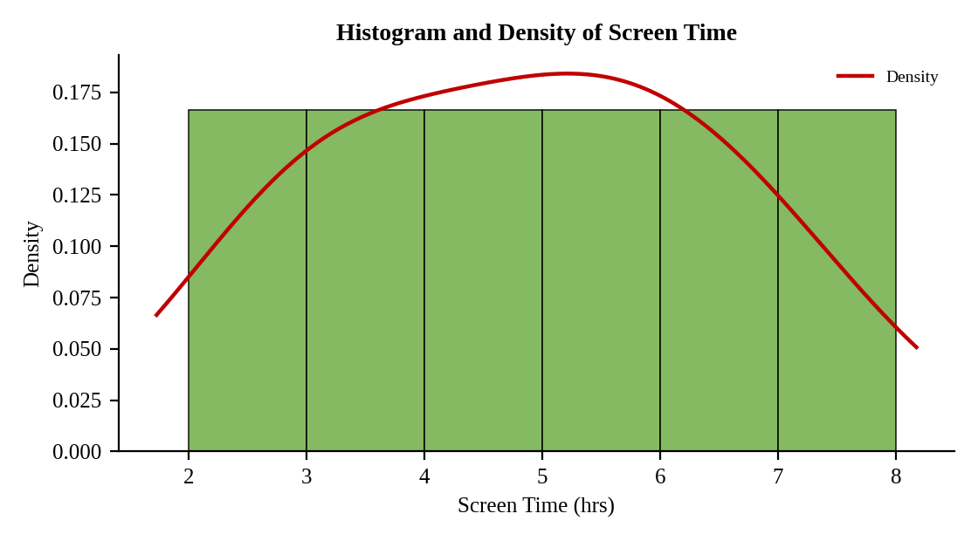
Interpretation:
Screen time ranges from 2.8 to 7.1 hours with a mean of 4.83 and a median of 4.95 hours. Each one-hour band between 2 and 8 hours holds exactly one user, so the distribution is nearly flat with no dominant peak: users are spread evenly from light to heavy.

Question 2. Create a scatter plot using R programming between Data_Used and Screen_Time. Calculate the correlation between them. Add a trend line. Explain the relationship.
Program (R):
r <- cor(usage$Screen_Time, usage$Data_Used)
r
ggplot(usage, aes(x = Screen_Time, y = Data_Used)) +
geom_point(size = 3, colour = "steelblue") +
geom_smooth(method = "lm", se = FALSE, colour = "red") +
annotate("text", x = 3, y = 4.3, label = paste("r =", round(r, 2))) +
labs(title = "Screen Time vs Data Used", x = "Screen Time (hrs)", y = "Data Used (GB)") +
theme_minimal()
Output:
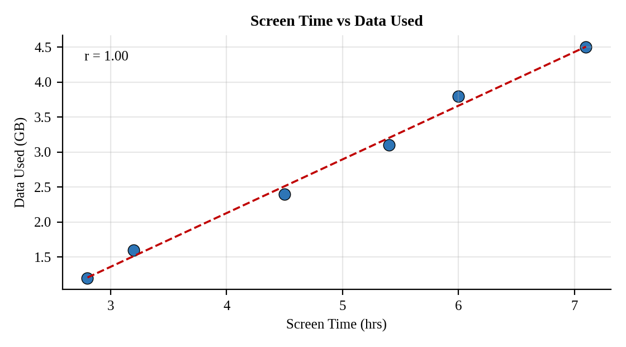
Interpretation:
The correlation is r = 1.00, an almost perfect positive linear relationship. The trend line shows about 0.77 GB of extra data for each additional hour of screen time, so users who spend longer on their phones consume proportionally more data.

Question 3. Using R, find the average Satisfaction score for each Gender. Create a bar chart for the averages. Add value labels. Interpret user satisfaction patterns.
Program (R):
avg_sat <- aggregate(Satisfaction ~ Gender, data = usage, FUN = mean)
avg_sat
ggplot(avg_sat, aes(x = Gender, y = Satisfaction, fill = Gender)) +
geom_col(colour = "black", width = 0.5) +
geom_text(aes(label = round(Satisfaction, 2)), vjust = -0.3) +
labs(title = "Average Satisfaction by Gender", x = "Gender", y = "Average Satisfaction Score") +
theme_minimal() + theme(legend.position = "none")
Output:
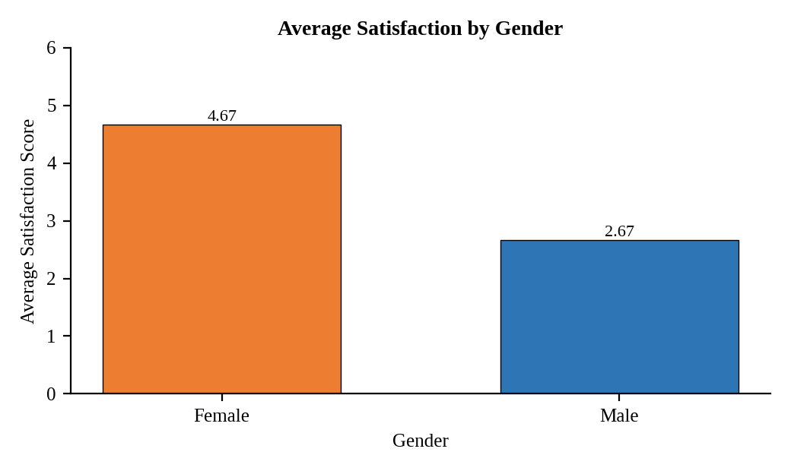
Interpretation:
Female users average 4.67 and male users 2.67 on the satisfaction scale. Satisfaction also follows usage: the female users have the higher screen time (5.4 to 7.1 hours) and the higher data use, and they are the more satisfied group. Male users, who use the app less, are noticeably less satisfied, which suggests the app may serve lighter users less well.

Question 4. Import Mobile_App_Usage.csv into Tableau. Create a bubble chart (Screen Time vs Data Used). Use color for Gender and size for App Usage Count. Create a line chart for usage trends. Add filters for Gender and Usage_Date. Design a mini dashboard.
Procedure (Tableau):
1. Open Tableau, click Connect, choose Text file / Microsoft Excel, select "Mobile_App_Usage.csv" and open Sheet 1.
2. Sheet 1 (Bubble): Columns = Screen_Time (SUM); Rows = Data_Used (SUM); Detail = User_ID; Color = Gender; Size = App_Usage_Count; mark type = Circle; set Opacity to 60%.
3. Sheet 2 (Line): Columns = Usage_Date (Month or Day, continuous); Rows = AVG(Screen_Time) and AVG(Data_Used); add labels.
4. Show the filters for Gender (Single value list) and Usage_Date (Range) and apply them to both sheets.
5. Click New Dashboard, name it "Mobile App Dashboard", set Size to Automatic and drag the sheets onto the canvas.
6. Select each chart and click the "Use as Filter" icon so that clicking a mark filters the other sheets; keep tooltips enabled.
7. Add a title to every sheet, adjust labels and colours, and save the workbook (File > Save As, .twbx).

Output:
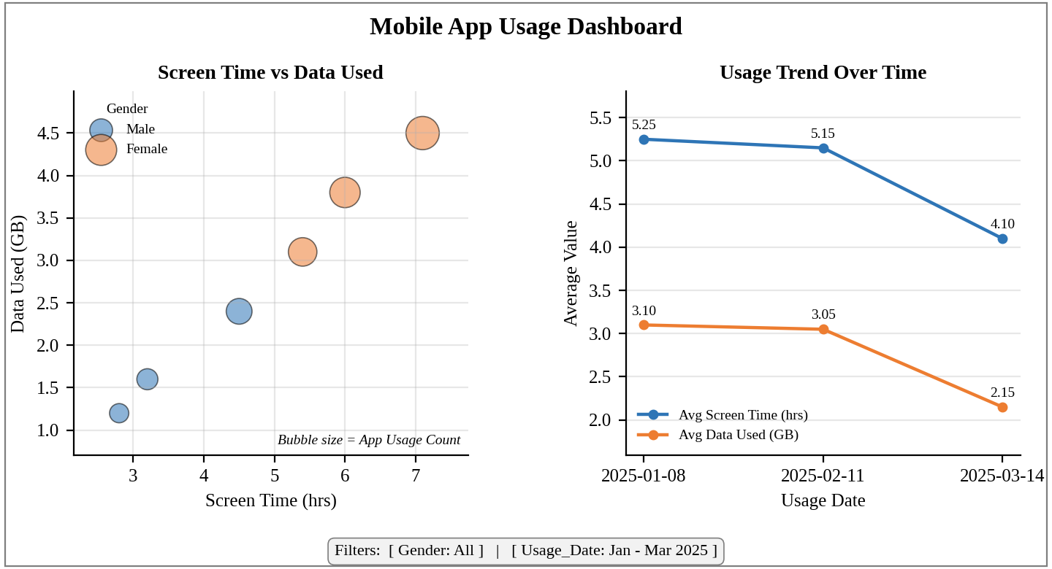
Dashboard layout (preview of the Tableau output).
Interpretation:
Female users form the upper-right cluster with the longest screen time, the most data and the largest bubbles (most app launches). Average screen time and data use both fall from January to March (5.25 to 4.10 hours and 3.10 to 2.15 GB). The Gender and Usage_Date filters update both views together.

